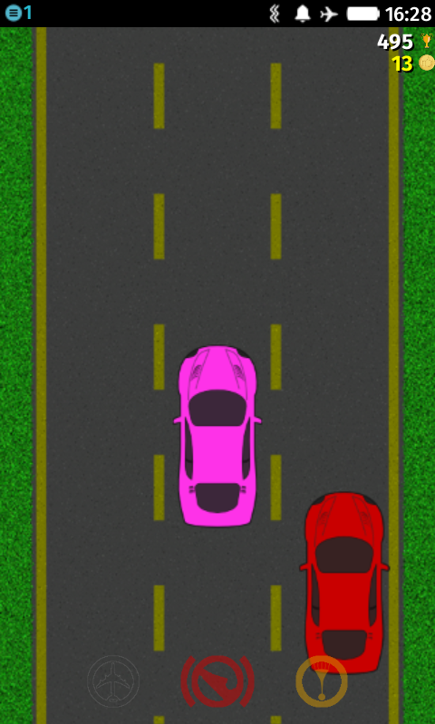**Car Racing Game**

**Overview:**

For my project I will be implementing a car racing game where the user will be playing against the computer (AI) in one road. To win the game, the user must get the finish line before the other car. However, throughout the game there will be obstacles (random objects) that hinders the user from winning spread in the road.

I will be using the pygame library to implement this game. The game will include three levels (easy – medium – hard) where in each level the AI speed will increase and more obstacles in the road.

The game will have a home page that will include two buttons play and help. And then when the user

clicks on play the game starts and the timer counts the time the user takes to reach the finish line. In addition to the obstacles across the road, that would make the user lose if he/she hits them.

Features:

* I will be adding powerups. These powerups will be the car go faster and they will be random. So, as the car hits the powerup the car speeds up.
* I will be implementing a timer where it counts the time in seconds where the user reached the finish line.

Checkpoint 1:

By November 24th, I will have created the basic template of the game. In addition to creating the AI.

Checkpoint 2:

By December 2nd, I will be adding the levels and objects in the road.